Entity Relationship Diagram (ERD) for a Loan Borrowing System:

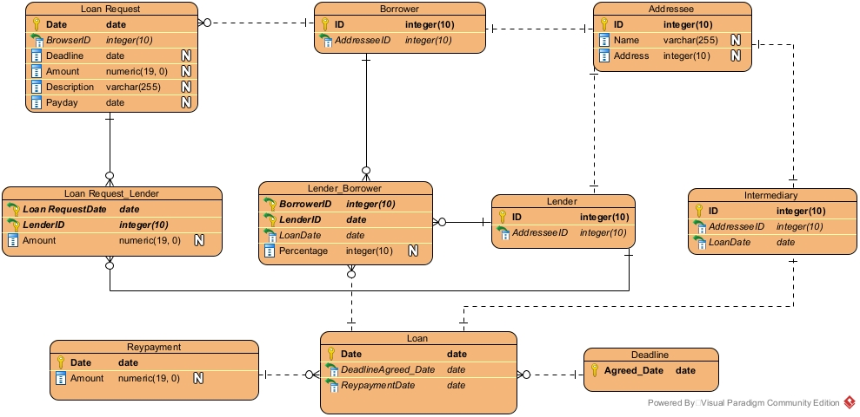

This ERD represents a loan borrowing system. It includes different entities such as Borrower, Lender, Loan Request, Loan, Repayment, Deadline, Addressee, and Intermediary, which together manage the complete loan process from request to repayment.
The Loan Request entity stores information about loan requests made by borrowers, including the request date, amount, deadline, description, and payday. Each loan request is made by one borrower, while a borrower can create multiple loan requests.
The Borrower entity represents a person who borrows money. Each borrower is linked to one Addressee that stores personal details like name and address. A borrower can be connected to many loan requests and can also be linked to multiple lenders through loan agreements.
The Lender entity represents the person or organization providing the loan. Like borrowers, each lender is connected to one Addressee. A lender can be involved in many loan requests and loan agreements with different borrowers.
The Loan Request_Lender entity connects loan requests and lenders. It shows which lender is willing to provide money for a specific loan request and the offered amount.
The Lender_Borrower entity represents the actual loan agreement between a borrower and a lender. It stores details such as loan date and interest percentage and connects borrowers, lenders, and loans.
The Loan entity represents an approved loan. Each loan has an agreed deadline and can have multiple repayments over time.
The Repayment entity stores repayment details such as date and amount. One loan can have many repayments.
The Deadline entity stores the agreed repayment date. One deadline can be shared by multiple loans.
The Intermediary entity represents a third party that helps manage loans. It is linked to one addressee and one loan.

